Kimmel Corporation
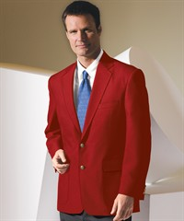
225 N. Sandusky Ave
Upper Sandusky, Ohio 43351
419-294-1959
mark.ratliff@kimmelcleaners.com
(Allow 2 weeks for delivery)

Name______________________________ Phone_____________________
Address____________________________________________________________
City_______________________________ State__________ Zip______________
Size_______________________ Email_________________________________

Deep Red Men’s 3500-12 Ladies 6500-12
100% Polyester Shell/ 100% Polyester Lining

Men Regular/Long: Size 36-50 Ladies: 4-22 $99.00

Men Regular/Long: Size 51-58 Ladies: 23-28 $109.00

* Price includes: Jacket, Ohio Elks Patch (not sewn on due to lodge’s use of different size name badges), Tax and Shipping.

* Returns are subject to $20.00 per blazer restocking fee.

*Prices can change without notice.

Check Number_________________________
Credit Card Number______________________________ Expiration_________ Type______
Code on back of card___________

