Kimmel Corporation
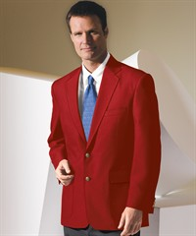
225 N. Sandusky Ave
Upper Sandusky, Ohio 43351
419-294-1959
sarah.schutt@kimmeluniform.com
(Allow 2 weeks for delivery)

Name______________________________ Phone_____________________
Lodge Address_____________________________________________________
City_______________________________ State__________ Zip______________
Size_______________________ Email_________________________________
Lodge and # ________________________________________________________
Deep Red Men’s 3500-12 Ladies 6500-12
100% Polyester Shell/ 100% Polyester Lining

Men Regular/Long: Size 34-48 Ladies: 0-22 $109.00

Men Regular/Long: Size 50-58 Ladies: 23-28 $119.00

Men Regular/Long: Size 60-62 $129.00

* Price includes: Jacket, Ohio Elks Patch (not sewn on due to lodge’s use of different size name badges), Tax and Shipping.

Credit Card Number______________________________ Expiration_________ Type______
Code on back of card___________

